FIW 2024 Registration + Agenda: Social Media Kit

About: It’s the 10th anniversary of Financial Inclusion Week (FIW), an annual virtual gathering of the global inclusive finance community. Hosted by the Center for Financial Inclusion (CFI), FIW offers participants a unique opportunity to exchange ideas, research, and perspectives from around the world. While reflecting on the progress of the past decade, this year’s FIW theme asks participants to think about “Financing the Future – Shaping the Next Decade of Inclusive Finance.”

Event Dates: October 15-18, 2024

In this Kit: Social Messages, Link to Social Cards

CTAs: Register for FIW24, View the 2024 Agenda

Links:
FIW Homepage – http://financialinclusionweek.org/
Registration & Agenda – https://bit.ly/CFI-FinclusionWeek

Tags:
- LinkedIn: @Center for Financial Inclusion
- Twitter: @CFI_Accion

Hashtags: #FIW24 #FinclusionWeek #financialinclusion #inclusivefinance #AI #climatechange #digitalization #resilience #consumerprotection

Main event image with registration CTA:

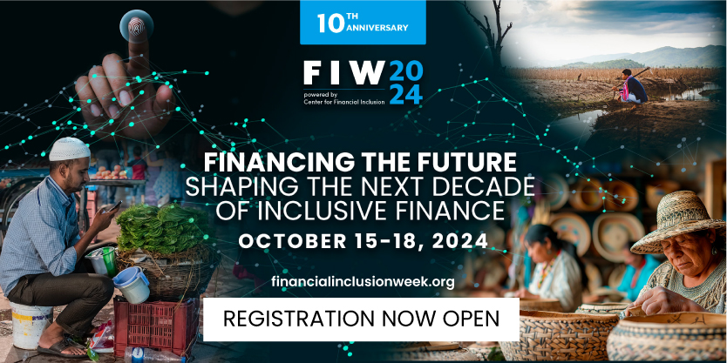

Full Messages [LinkedIn, Facebook]

It’s been 10 years since the inception of #FinclusionWeek, a time for industry leaders and experts from around the world to collaborate and share insights that push the #financialinclusion needle further. This year, in celebration of the 10th anniversary, FIW is a chance for us to reflect on the past decade of #inclusivefinance– how far we’ve come and what progress has been made– and consider what is needed to continue advancing inclusive financial systems that create positive outcomes for all.

Join us this year for Financial Inclusion Week 2024, taking place virtually October 15-18. View this year’s exciting live agenda and register today: https://bit.ly/CFI-FinclusionWeek
@Center for Financial Inclusion (CFI)

#FinclusionWeek 2024 Registration is Now Open!
Save the Date: October 15-18, 2024

Don’t miss out on the 10th anniversary of the leading industry event on #financialinclusion. FIW is a unique chance to meet peers, share innovative solution and learn from new perspectives, and collectively discuss the future of #inclusivefinance. Register today to view our exciting live agenda and get ready for a week of thought-provoking and insightful learnings.

View the agenda and register for #FIW24: https://bit.ly/CFI-FinclusionWeek

#FinclusionWeek 2024 registration is now open!
Check out the exciting #FIW24 10th anniversary agenda and register for a week full of engaging conversations taking place Oct. 15–18 that address” “Financing the Future – Shaping the Next Decade of Inclusive Finance.”
Convened by Center for Financial Inclusion (CFI)
https://bit.ly/CFI-FinclusionWeek #financialinclusion

This year is the 10th anniversary of #FinclusionWeek! Join me and the global #financialinclusion community Oct. 15-18 as we explore what solutions to implement now to propel financial inclusion forward and ensure everyone can use responsible financial services.
Convened by Center for Financial Inclusion (CFI)
Register and view the full #FIW24 agenda today: https://bit.ly/CFI-FinclusionWeek

Join us for the 10th anniversary of Financial Inclusion Week!

Today, #FSPs have expanded to include #fintechs to #bigtech, and the use of #AI is widespread across product and service design and delivery. With the Global #Findex Report finding that 76% of adults and 74% of #women have financial accounts, we must now look beyond access to usage and quality outcome indicators. What solutions can we implement now to propel financial inclusion forward and ensure everyone can use responsible financial services to make informed decisions and improve their lives?

Every year, Center for Financial Inclusion (CFI) convenes #financialinclusion stakeholders from around the world to discuss the pressing topics of inclusive finance. This year’s event will present an industry-wide opportunity to reflect on how the inclusive finance sector has evolved over the past decade and what we need to do next to serve the nearly 2 billion people that remain excluded from the formal financial system.

Register and view the full #FIW24 agenda today 👉 https://bit.ly/CFI-FinclusionWeek

#FinclusionWeek is back for its 10th anniversary! Financial Inclusion Week is a forum for exchanging ideas, research, and perspectives from around the world. Register for #FIW24, convened by Center for Financial Inclusion (CFI), and join the conversation on how to serve the nearly 2 billion people that remain excluded from the formal financial system.
Register here: https://bit.ly/CFI-FinclusionWeek

Shorter Messages [Twitter-Friendly]
#FinclusionWeek 2024 registration is officially open!

Check out @CFI_Accion's exciting agenda and register to join on Oct. 15–18 for a week full of engaging conversations that address: “Financing the Future – Shaping the Next Decade of Inclusive Finance.” #financialinclusion https://bit.ly/CFI-FinclusionWeek

This year's #FinclusionWeek is bigger than ever. Join @CFI_Accion on Oct. 15–18 to explore how the #inclusivefinance sector can responsibly serve the nearly 2 billion people that remain excluded.
View the full #FIW24 agenda by registering today 👉 https://bit.ly/CFI-FinclusionWeek

#FinclusionWeek 2024 registration and agenda are live!
Register for #FIW24 📲
View the full agenda
Spread the word📣 🗣️

Convened by @CFI_Accion 👇
https://bit.ly/CFI-FinclusionWeek

Social Media Images

